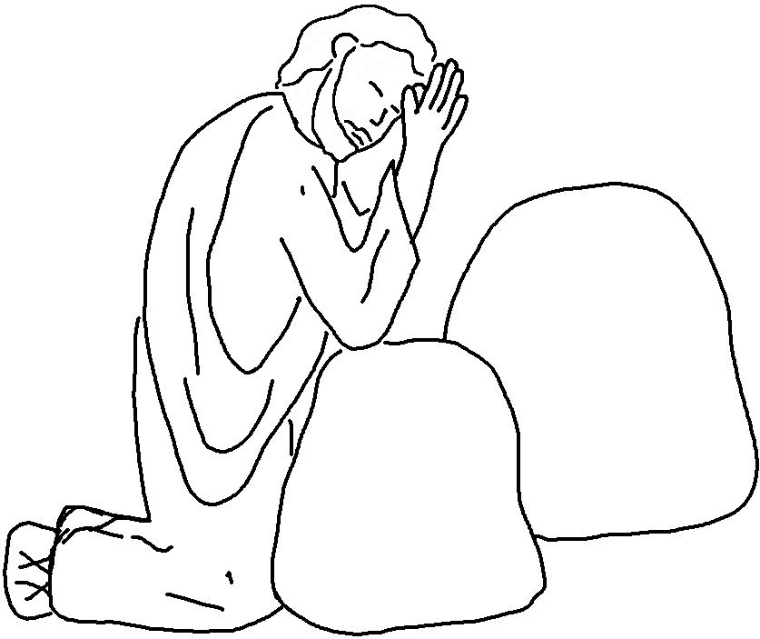
Give us today the food we need,
and forgive us our sins,
as we have forgiven those who
sin against us.

Matthew 6:11, 12 _{NLT}

